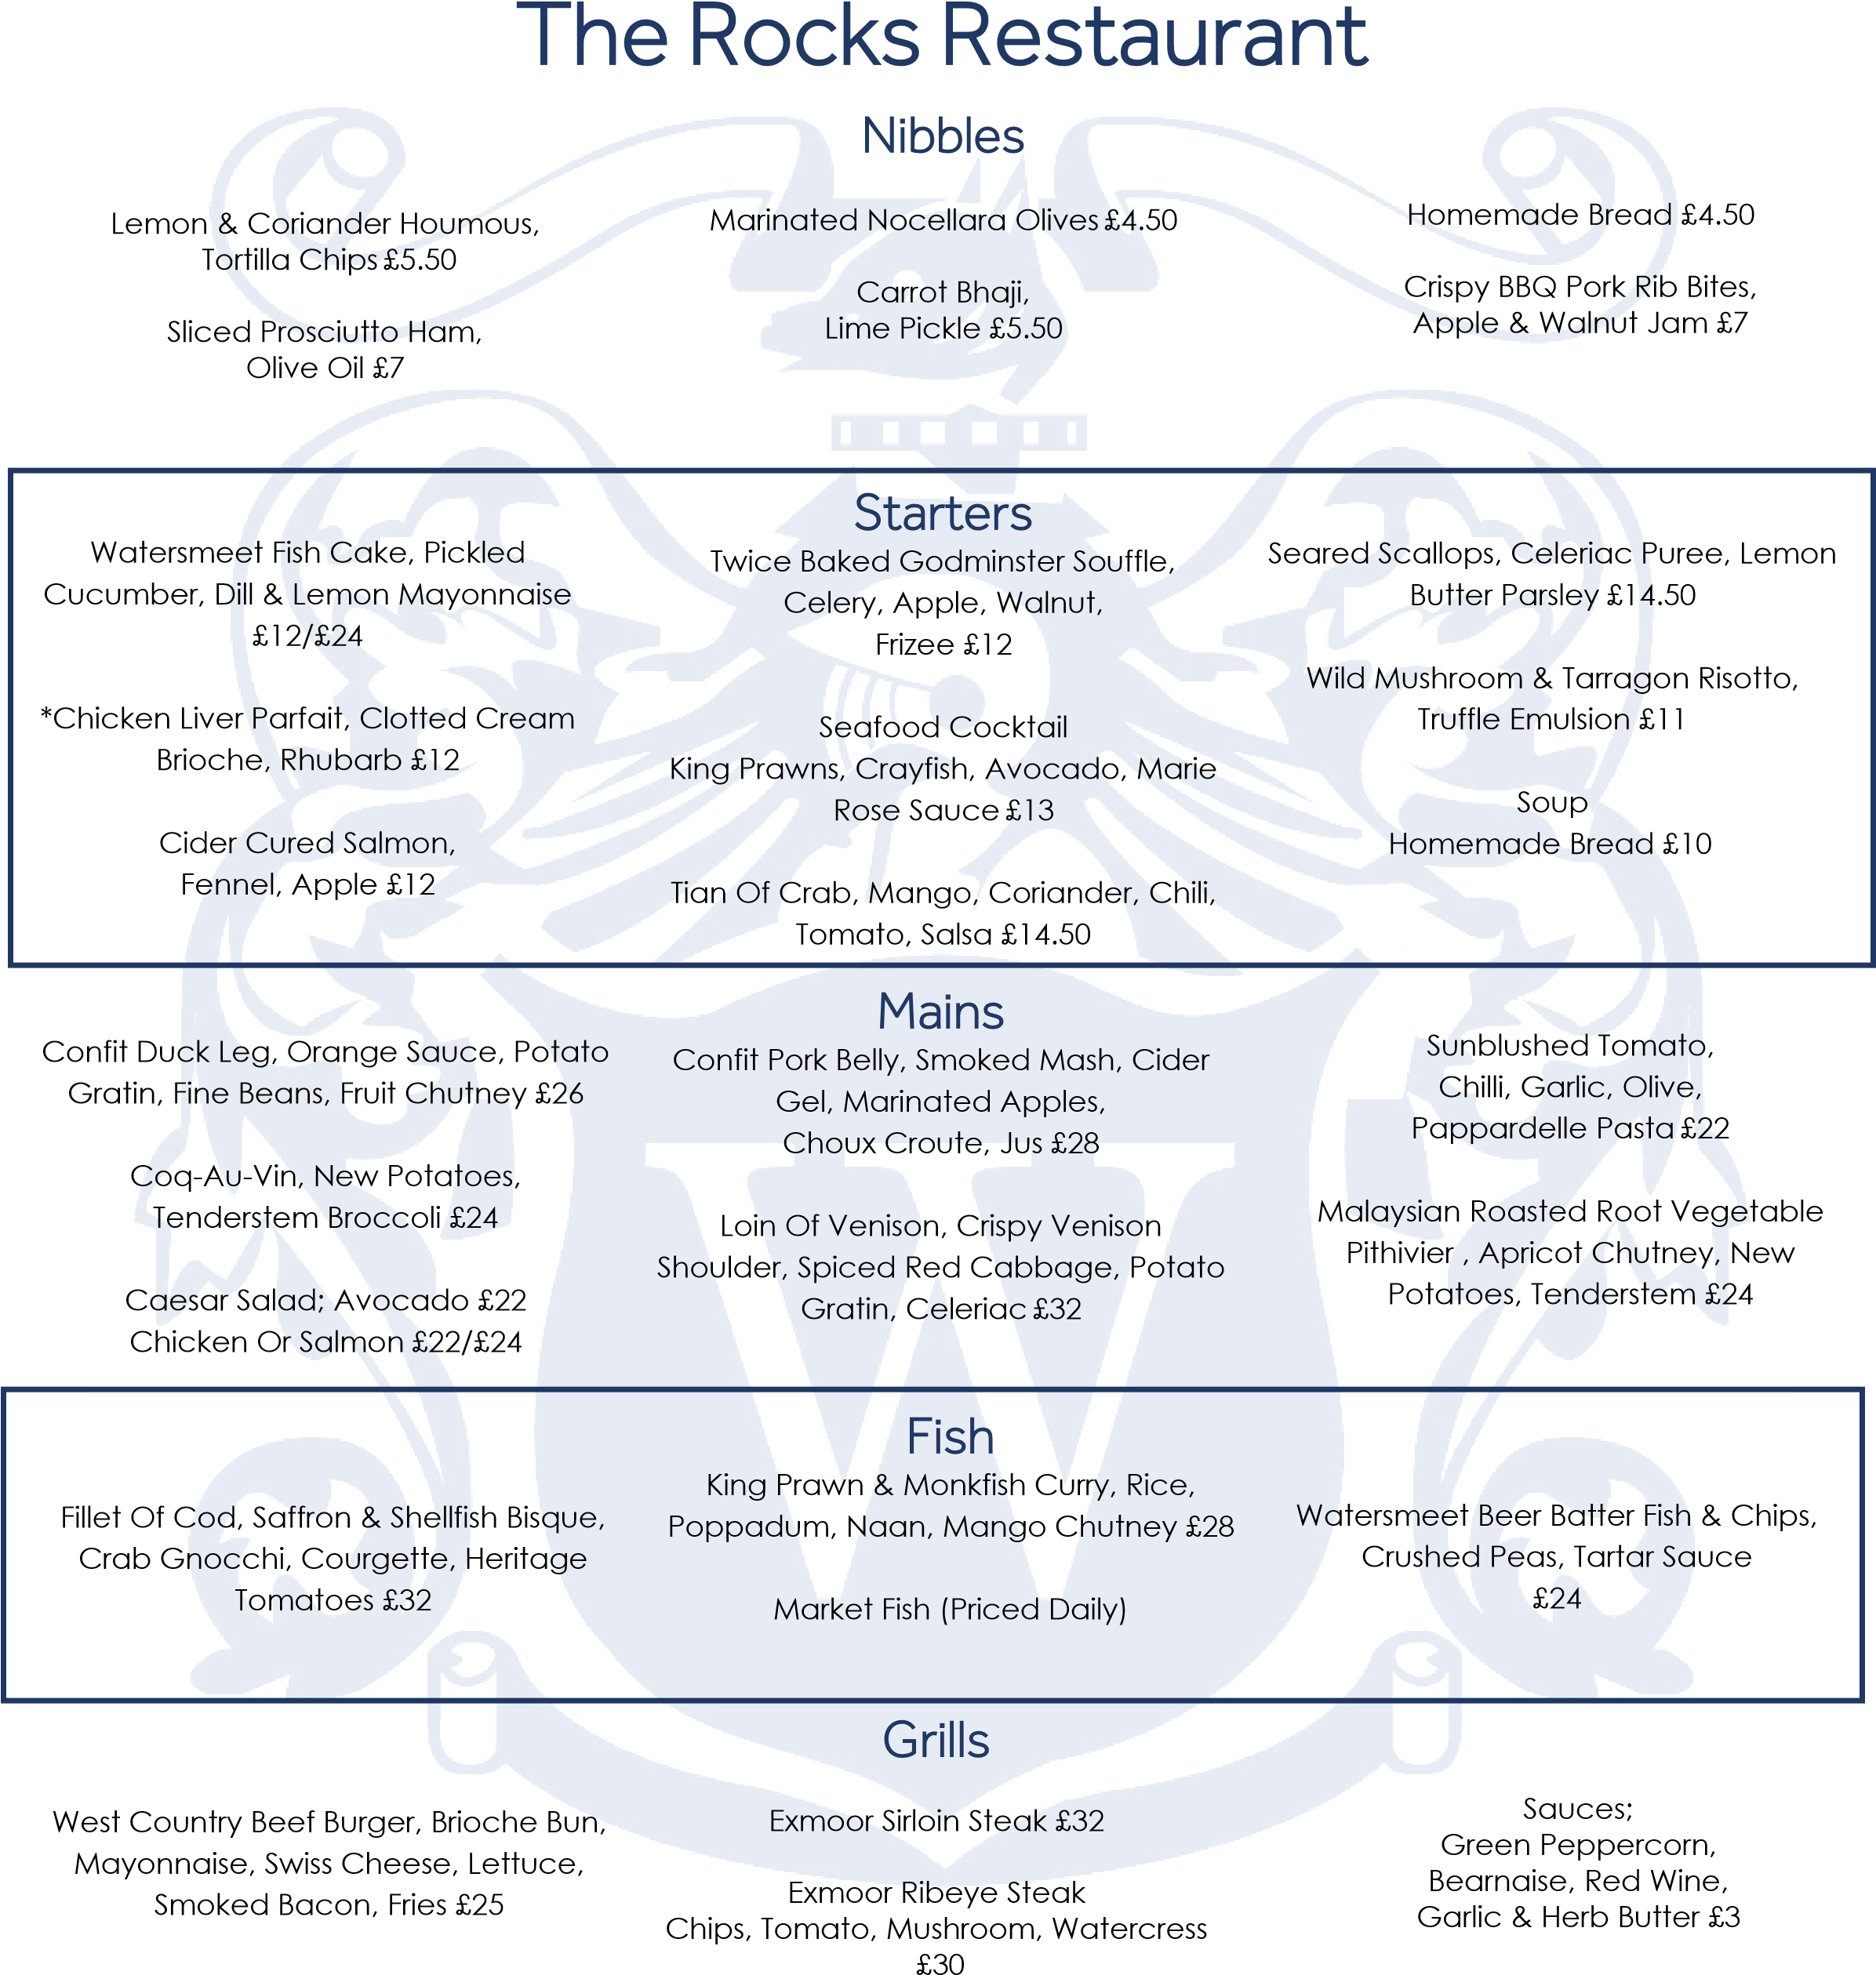

Hand Cut Chips £5.50  French Fries £5.50 | Sides  Seasonal Salad £6  Fine Green Beans £6  Tenderstem Broccoli £6 |  | Minted New Potatoes £6  Honey Roasted Carrots £6

